**NSSA221 Systems Administration I**

**Lab 05 Report**

# Name: Marveh Mustafa - Rania Kanaan - Suhaila Alfalasi - Saeed Falaknaz - Alia AlYammahi Grade ___/50

**Requirements:**

Use this document to answer questions related to Lab 04. Submit this template to the LR04 drop box by the due date. Late submissions are subject to a 20% penalty. You must use this template and submit the document in Microsoft Word any other format will result in a zero grade for the report.

When submitting your material, please use the following format; LRXX, followed by an underscore, and the first initial of your first name in uppercase, and your entire last name with the first letter in uppercase. Example: LR04_GArcoraci.doc.

Answer ALL questions in your OWN words. Your answer should give some indication that you understand the topic in question and can relate it to your experience in the lab, and not a general textbook answer. DO NOT copy and paste or plagiarize. You may use an outside resource and cite it accordingly to support your answer, but it should **NOT** be your entire answer.

Your answers must be complete sentences and use proper sentence structure. Phrases or one word responses will receive a zero.

1. (5 points) What does the following rsync command do? Be specific.

**rsync -av host::src /dest**

The rsync -av host::src /dest command will first call the rsync utility, and connect to the daemon remote machine called host and it will then simultaneously add the source directory with the dest directory, and it will keep the file attributes and providing the output of the process that is list of the files that have been transferred from the source to the destination.

1. (10 points) From the client, could you view the file that was transferred to the FTP server at the completion of Activity 4? Explain why or why not? How could you verify that the file was transferred?

Yes, because I had access to the FTP server logs and was therefore able to look into the transmitted file. To ensure that the file was successfully transmitted, we may use an FTP command such as 'ls -a', which is what we used in this activity. We may also look at the FTP server logs to see if the file was successfully transmitted.

1. (15 points) Explain the *samba.conf* file format in **your own words**. What are the three special sections and there intended purpose?

. the smb.conf file format is the configuration for samba it is a implementation of the networking protocols which allows system to share files and other services across the network, the three special sections are global,homes,printers,where the global is used to make the global settings that apply to the samba server like workgroup,security settings, the home section allows us to create home directory for each user who logs in as well as sharing the directories , printer allows us to configure the settings for printer sharing, it allows the users that have permissions to print, overall these sections are made to make these resources easier to make and use.

1. (15 points) Explain the three options (rw, sync, and no_root_squash) that were used when creating the entry in the exports file in Activity 8. Include in your answer the advantages and disadvantages of using the synchronous (sync) and asynchronous modes. Explain the security implications of using the “no_root”squash” option.

The rw (read-write) permission allows users to read and write to the directory, although it may result in some users modifying or destroying the contents in the directory. The synchronous (sync) mode is used to transport and write data to disk in the form of blocks. The asynchronous mode is a data transfer method that employs flow control; data is sent in the form of bytes. Because it solves problems in real-time, synchronous is substantially faster than asynchronous. However, one drawback of synchronous mode is that users must operate at the same time, whereas in asynchronous mode, users do not need to work at the same time. The no_root_squash option allows the client's root user to read and modify NFS server files with root-level permissions, possibly creating a security risk by circumventing NFS security procedures.

(5 points) What is the purpose of the “_netdev” in the fstab file when mounting to an NFS export?

the purpose is to show that that filesystem is depending on the networking up and being active and then mounting to it and _netdev does is a mount order that informs the system that the file system should be mounted, and it also unmounts the filesystem before the network is shutdown, so _netdev makes sure that system looks at the system status when handling filesystem.



**All screenshots must be labeled using the following titles.**

**Figure 1** – Forward Lookup Zone

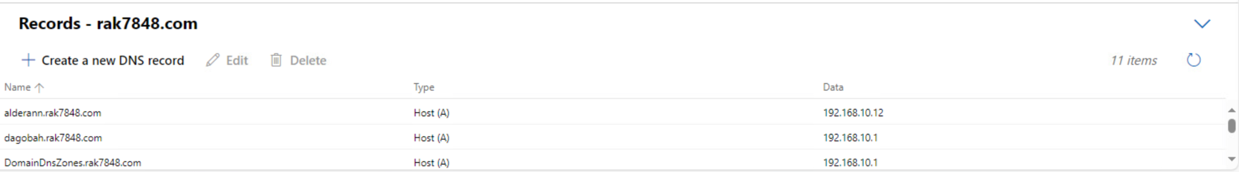







**Figure 2** – Reverse Lookup Zone

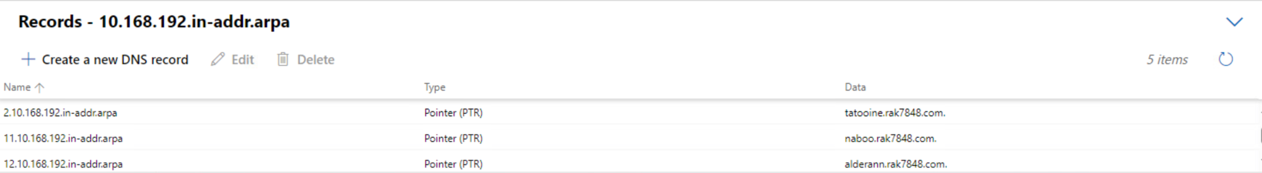



**Figure 3** – Rsync History

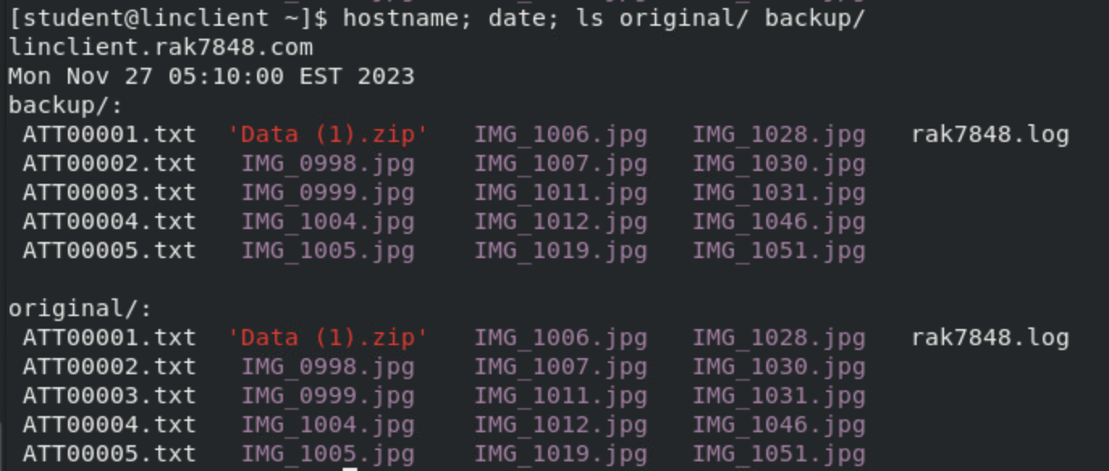

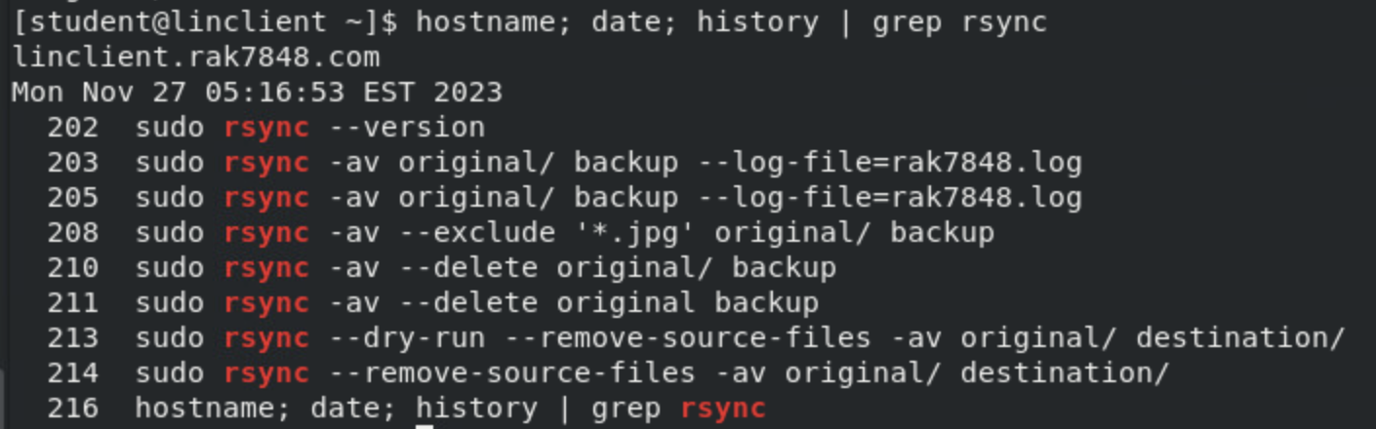

**Figure 4** – FTP User Login

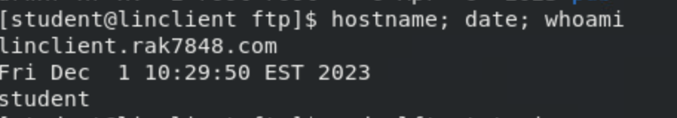

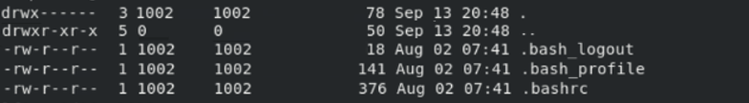

**Figure 5** – FTP Anonymous Login

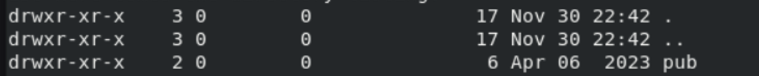

**Figure 7** – Remote Samba Access and Write Verification

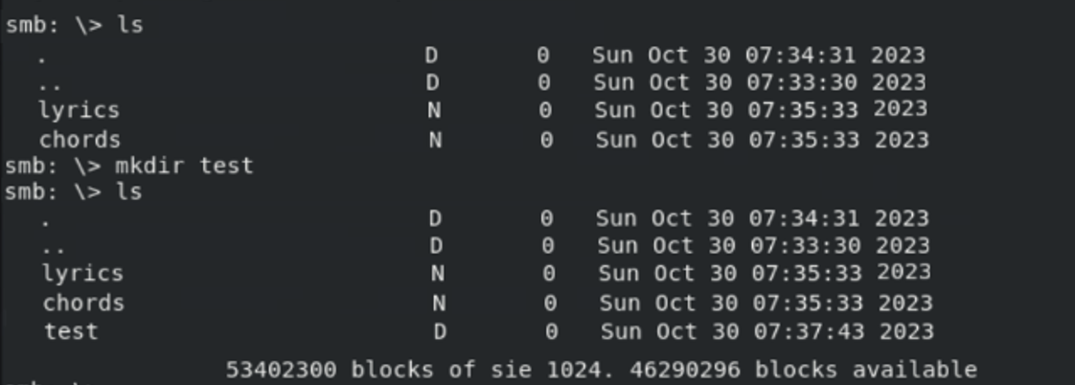

**Figure 8** – Windows Client Samba Verification

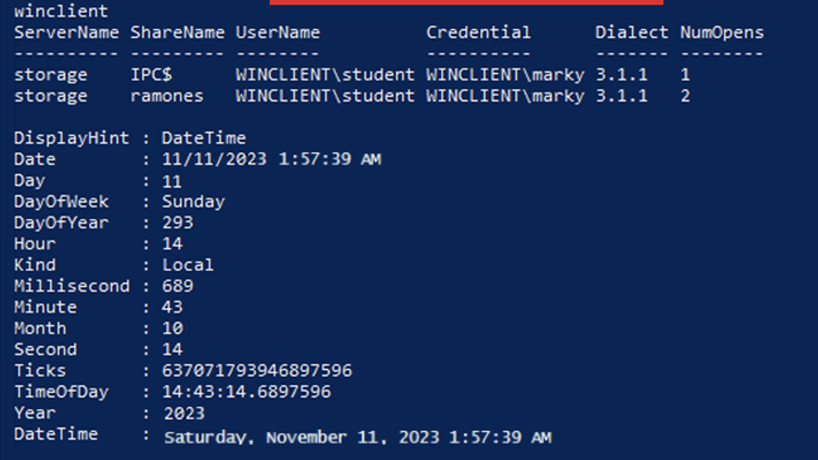

**Figure 10** – RSYNC File Transfer



**Figure 11** – Linux Client NFS Verification

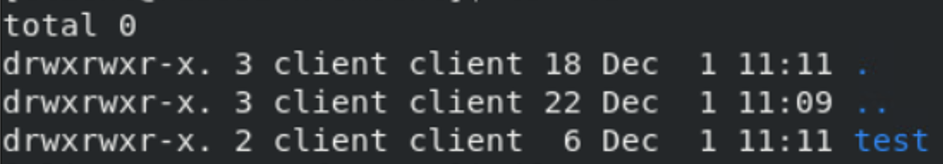

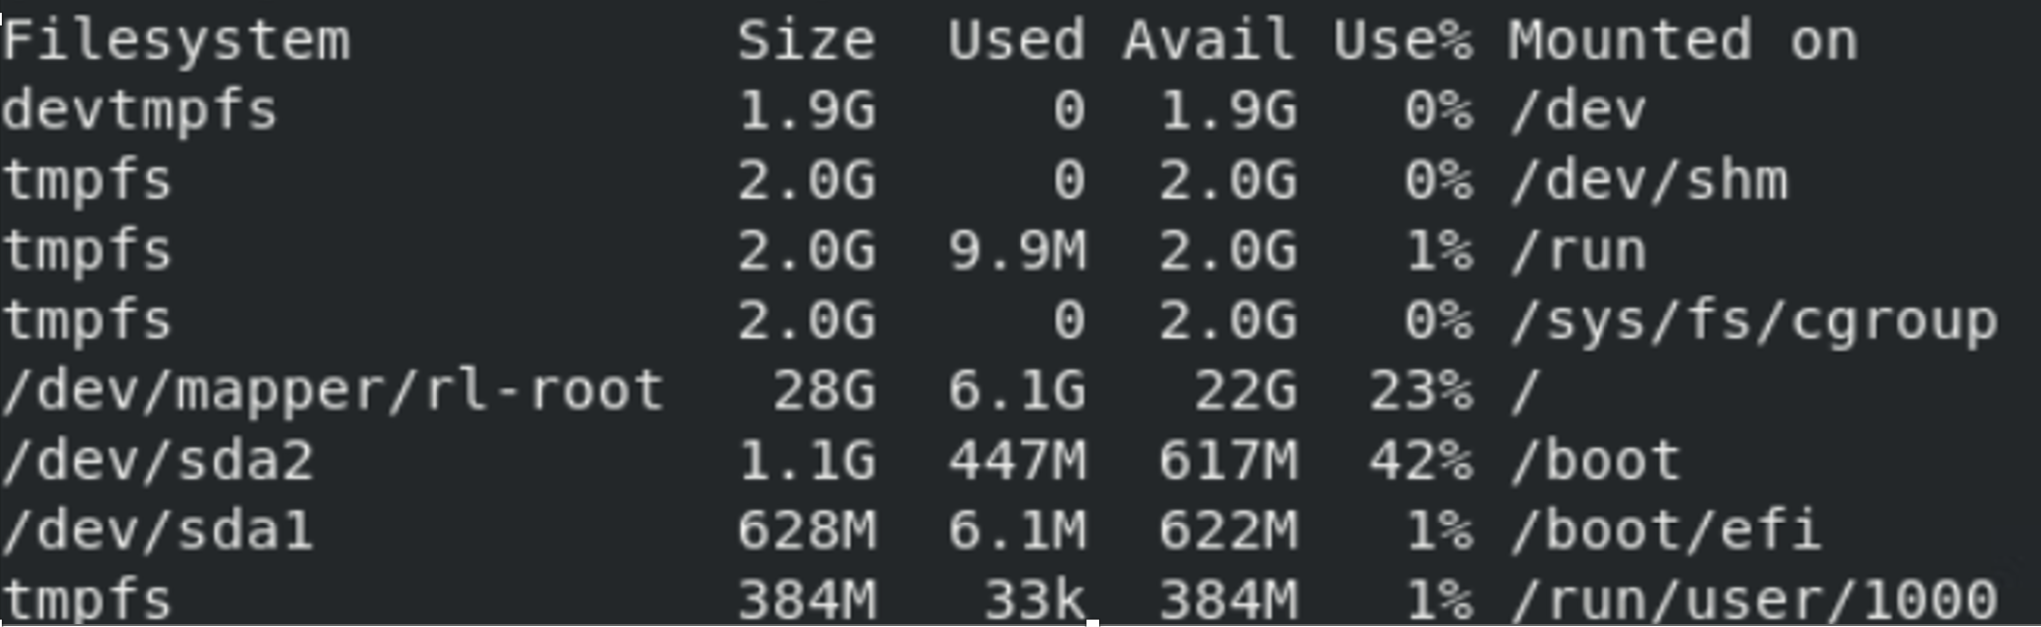

**Figure 12** – Windows NFS Write Verification

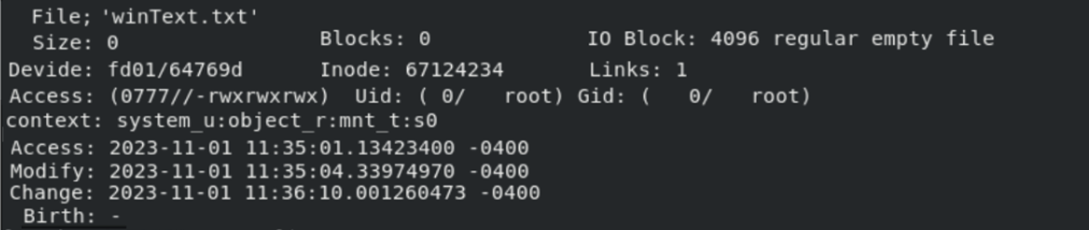

**Figure 13** – NFS Network Connection Verification

